MOTION
From 1D Kinematics to Projectile Motion
Contents
1. One-Dimensional Motion
2. Example: Falling Object
3. Example: Moving Car
4. Two-Dimensional Projectile Motion
5. Derivation: Parabolic Equation
6. Derivation: Maximum Height & Range
7. Formula Summary Table
8. Problem 1: Football Kick
9. Problem 2: Cliff Launch
10. Projectile Motion & Software Engineering

1. One-Dimensional Motion
One-dimensional (1D) motion describes the movement of an object along a single straight line either horizontal (like a car) or vertical (like a falling object). It is the foundation of all kinematics.

1.1 Equations of Motion (1D)
The three fundamental equations for uniform acceleration:

Eq. 1 | v = u + at

Eq. 2 | x = ut + ½at²

Eq. 3 | v² = u² + 2ax

Where: u = initial velocity, v = final velocity, a = acceleration, x = displacement, t = time
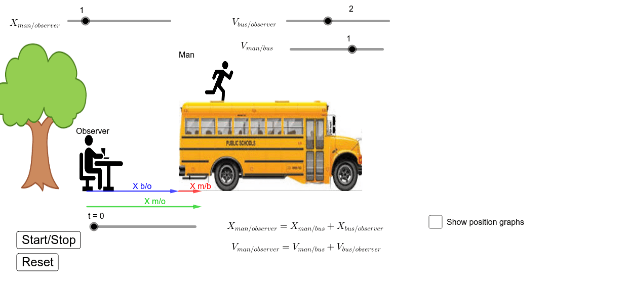

2. Example: Falling Object (Free Fall)
A ball dropped from rest under the influence of gravity is the simplest 1D motion example. Gravity provides a constant downward acceleration of g = 9.8 m/s².


2.2 Equations Applied
Velocity | v = gt

Height fallen | h = ½gt²

Impact speed | v² = 2gh

Key Insight: The velocity increases linearly with time (v-t graph is a straight line), while the distance fallen grows as a parabola (h-t graph is curved).

3. Example: Moving Car
A car provides two classical 1D scenarios — uniform motion and uniformly accelerated motion.

3.1 Uniform Motion (Constant Speed)
- Velocity: v = constant
- Acceleration: a = 0
Displacement | x = vt
The position-time graph is a straight line. The velocity-time graph is horizontal.
3.2 Uniformly Accelerated Motion
- Initial velocity: u (may be 0 or non-zero)
- Constant acceleration: a > 0
Position | x = ut + ½atv²

The position-time graph is parabolic. This is the same shape we will see in projectile motion!

4. Two-Dimensional Projectile Motion
Projectile motion occurs when an object is launched with an initial velocity at an angle θ to the horizontal and then moves freely under gravity. The key insight is that the horizontal and vertical components of motion are completely independent.

Initial Conditions
- Initial speed: v₀ Launch angle: θ (above horizontal)
- Horizontal component: v₀_{x} = v₀cosθ Vertical component: v₀_{y} = v₀ sinθ
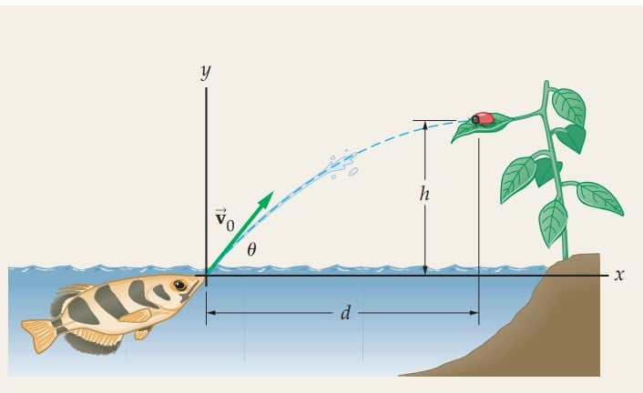

Characteristics of Projectile motion:
1. Projectile motion is a fine example of curvilinear motion which is two dimensional.
2. The position and velocity change continuously with time.
3. The acceleration is constant and always directed vertically downward. It has no horizontal acceleration.

State the assumptions we make in the ideal projectile motion model.
Answer:
  - Acceleration due to gravity is constant (≈ 9.8 m/s²).
  - Air resistance is neglected
  - The ground is level and flat.
  - The arrow is treated as a point mass.
  - The only force acting after launch is gravity

4.2 Motion Along Each Axis
Horizontal axis (x): No force acts horizontally → constant velocity
Horizontal | x = v₀cosθ · t
Vertical axis (y): Gravity acts downward → constant deceleration
Vertical | y = v₀sinθ · t - ½gt²

5. Derivation: Parabolic Equation
The equation of Projectile path or trajectory: Let us consider a projectile begins its flight with an initial velocity $V_{0}$ and making an angle θ with the horizontal direction from point O as shown in Fig. 1.
The initial velocity has two components i.e.,
Horizontal component, $V_{ox}=V_{o}Cosθ$, along OX-direction and,
Vertical component, $V_{oy}=V_{o}Sinθ$, along OY-direction.
The accelerations components are $a_{x} = 0$, along horizontal direction
And $a_{y} =-g$, along vertical direction
At any time t, the horizontal and vertical components of displacement of a projectile are given by,
$$x = V_{ox} t + \frac{1}{2}a_{x}t^{2}$$
or,$x =V_{o}Cosθt$ ; (since a_{x} = 0)

and,
$$y = V_{oy} t + \frac{1}{2}a_{y}t^{2}$$
$$y = V_{o}Sinθ t- \frac{1}{2}gt^{2}$$

Now, at time t, the horizontal and vertical components of velocity of a projectile are given by, Horizontal Component $V_{x}=V_{0}Cosθ$
Vertical Component $V_{y}=V_{0}Sinθ-gt$
So, at time t, the magnitude of velocity of a projectile is,
$$V=\sqrt{{(V}_{x}^{2}}+V_{y}^{2})$$
Let v makes an angle θ with the x axis, so
$$tanθ =\frac{V_{y}}{V_{x}}$$
$$θ =\tan^{1}\left(\frac{V_{y}}{V_{x}}\right)$$
which represent the direction of the projectile.
The horizontal velocity component of a projectile remains unchanged over time because there is no time dependent term as shown. On the other hand, the vertical velocity component of a projectile changes with time

Explain mathematically why the trajectory of a projectile launched an angle follows a parabolic path.  Parabolic Path y = x tanθ - gx² / (2v₀²cos²θ)  Answer: Let a projectile be launched with:  - Initial velocity:  - Angle of projection: θ  Horizontal position: $X\left(t\right)=V_{0}Cosθ*t$  From horizontal motion:$t=\frac{x}{V_{0}cosθ}$  Vertical position: $y\left(t\right)=V_{o}sinθ*t-\frac{1}{2}gt^{2}--(1)$  Substitute the value of t in equation (1) we get,  $$y=V_{0}Sinθ*\left(\frac{x}{V_{0}Cosθ}\right)-\frac{1}{2}g{\left(\frac{x}{V_{0}Cosθ}\right)}^{2}$$  $$y=Xtanθ-\left(\frac{\frac{1}{2}g}{V_{0}^{2}\cos^{2}{θ}}\right)*X^{2}----- (2)$$  $$y=aX-{bX}^{2 } Equation of trajectory$$  Where a=$tanθ, b=\frac{\frac{1}{2}g}{V_{0}^{2}\cos^{2}{θ}}$  This is the equation of trajectory in projectile motion, and it proves that the projectile motion is always parabolic in nature. | Time to reach maximum height A:  Time of Flight T = 2v₀ sinθ / g  At maximum height, the vertical component of velocity, $V_{y}$= 0  From the equation of motion,$V_{y}=V_{0}Sinθ-gt$  $$Or, t = \frac{V_{0}Sinθ}{g} ----------(3)$$  Time to reach at ground point B:  At minimum height, the vertical component of velocity, $V_{y}$=$V_{0}Sinθ$ and initial velocity is at point A is zero  From the equation of motion,$V_{y}=U-gt$  $$Or, t = \frac{V_{0}Sinθ}{g} ----------(4)$$  Total flight time:  T= Time to reach maximum height A+ Time to reach at ground point B  $$T= \frac{2V_{0}Sinθ}{g}$$
Max Height H = v₀² sin²θ / (2g)  The object’s maximum height is the highest vertical position along its trajectory. From the equation of motion $V^{2}={V_{oy}}^{2}-2gH$  At maximum height final velocity is zero and initial vertical velocity, $V_{oy}=V_{o}Sinθ$  $$0={{(V}_{o}Sinθ)}^{2}-2gH$$  The maximum height is given by,  $$H=\frac{V_{0}^{2}Sin^{2}θ}{2*g}$$ | Horizontal Range:  The linear distance from the point of projection to the end of flight is called the horizontal range. Alternatively, the distance travelled along the horizontal direction in the time of flight is called the horizontal range. This is denoted by R.  R = horizontal component of the initial velocity × time of flight  $$R=V_{0}Cosθ*T$$  $$R=V_{0}Cosθ*T=\frac{2V_{0}Sinθ}{g}$$  $$R=\frac{V_{0}^{2}2SinθCosθ}{g}$$  $$R=\frac{V_{0}^{2}Sin2θ}{g}$$
Maximum Horizontal Range:
Range | R = v₀² sin(2θ) / g

The equation of horizontal range
$$R=\frac{V_{0}^{2}Sin2θ}{g}$$

It is evident that R will be maximum, when $sin2θ = 1$

$$sin2θ =Sin90°$$
$$2θ = 90°$$
$$θ = 45°$$

In that case,
$$R{}_{max}=\frac{V_{0}^{2}}{g}$$

If an object is thrown at an angle 45⁰ with the horizontal direction, the horizontal range will be maximum.

7. Formula Summary Table
All derived formulas for projectile motion:

Formula | Expression | Notes
Horizontal velocity | vx = v₀cosθ | Constant throughout
Vertical velocity | vy = v₀sinθ - gt | Changes with time
Horizontal position | x = v₀cosθ · t | Uniform motion
Vertical position | y = v₀sinθ · t - ½gt² | Parabolic
Parabolic equation | y = x tanθ - gx² / (2v₀²cos²θ) | Equation of path
Max Height | H = v₀²sin²θ / (2g) | At v_{y} = 0
Time of Flight | T = 2v₀sinθ / g | Total airborne time
Range | R = v₀²sin(2θ) / g | Max at θ = 45°

8. Problem 1:

A hunter fires an arrow with an initial velocity of 40 m/s at an angle of 60° above the horizontal. A tree is located 100 meters away with height 50m and a deer located 110m away from position o begins to run from behind the tree at the exact moment the arrow is released, moving away from the hunter at a speed of 7 m/s.

1. Mathematically show that after time t=3 sec and t=5 sec the horizontal component remains same whereas vertical component changes.  Answer: General form of Horizontal Component $V_{x}=V_{0}Cosθ$  Vertical Component $V_{y}=V_{0}Sinθ-gt$  At t = 2 s:  Horizontal Component $V_{x}=V_{0}Cosθ=40Cos60°=20{ms}^{-1}$  Vertical Component $V_{y}=V_{0}Sinθ-gt=40Sin60°-\left(9.8*2\right)=15.04ms^{-1}$  At t = 3 s:  Horizontal Component $V_{x}=V_{0}Cosθ=40Cos60°=20{ms}^{-1}$  Vertical Component $V_{y}=V_{0}Sinθ-gt=40Sin60°-\left(9.8*3\right)=5.24ms^{-1}$ | 2. Calculate the velocity of arrow after t=2sec and t=3sec  Answer: The final velocity after time t is given by,  $$V=\sqrt{{(V}_{x}^{2}}+V_{y}^{2})$$  At t=2 sec, $V_{x}=20{ms}^{-1}$, $V_{y}=15.04ms^{-1}$  $$V=\sqrt{{20}^{2}+{15.04}^{2}}=25.02ms^{1}$$  At t= sec, $V_{x}=20{ms}^{-1}$, $V_{y}=5.24ms^{-1}$  $$V=\sqrt{{20}^{2}+{5.24}^{2}}= 20.67ms^{-1}$$  3. Calculate  - Maximum Height  Answer: The maximum height is given by,  $$H=\frac{V_{0}^{2}Sin^{2}θ}{2*g}=\frac{{40}^{2}Sin^{2}60}{2*9.8}=61.2m$$  - Total Flight Time  The total flight time is given by,  $$T=\frac{2V_{0}Sinθ}{g}=\frac{2*40*Sin60}{9.8}=7.07sec$$
5. Will the arrow the wall or pass over it? Show your calculations.  Answer: To reach the tree the time taken by arrow is,  $$X\left(t\right)=V_{0}Cosθ*t$$  $$100=40*Cos60*t$$  $$t=5 sec$$  The height of arrow at time t=5sec is,  $$y\left(t\right)=V_{o}sinθ*t-\frac{1}{2}gt^{2}$$  $$y\left(5\right)=40sin60*5-\frac{1}{2}*9.8*5^{2}$$  $$y\left(5\right)=50.7m$$  The arrow reaches a height of 50.7 m when it is horizontally aligned with the tree. Since the tree is 50 m tall, the arrow will just pass over the top by 0.7 meters. | If the arrow must just hit the top of the tree, what should the initial velocity be?  Answer: Since we know the height of arrow at certain distance x is given by  $$y=Xtanθ-\frac{1}{2}g{\left(\frac{x}{V_{0}Cosθ}\right)}^{2}$$  To hit the tree at top x=100m and y=50m. Substituting this value we get,  $$50=100tan60°-\frac{1}{2}*9.8*{\left(\frac{100}{V_{0}Cos60°}\right)}^{2}$$  After doing some mathematical calculations we get,  $$V_{0}=39.87ms^{-1}$$  To just hit the top of the 50-meter wall at 100 meters away, the arrow must be launched at an initial velocity of approximately 39.9 m/s at 60°.
8. Explain mathematically, whether arrow hit the deer or not.
Answer:
The total flight time
$$T=\frac{2V_{0}Sinθ}{g}=\frac{2*40*Sin60}{9.8}=7.07sec$$

At that time distance cover by deer is ,
$$S=vt=7*7.07=49.40m$$
Deer position at that time S’=110+49.40=159.40m
The range of arrow is given by,
$$R=\frac{V_{0}^{2}Sin2θ}{g}=\frac{{40}^{2}Sin(2*60)}{9.8}=141.4m$$
Arrow falls short by 18m. Mathematically, the arrow will not hit the deer.

Problem: The projectile is thrown at 252–√2 m/s at an angle of 45°. If the object is to clear both posts, each with a height of 30m, find the minimum: (a) position of the launch on the ground in relation to the posts and (b) the separation between the posts.
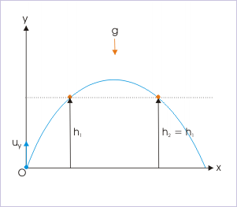
The first thing we need to di is figure out at what time t the object reaches the specific height. Since the motion is parabolic in nature, this will occur twice: once when traveling upward and again when the object is travelling downward. For this case we can use the equation of displacement in the vertical direction
$$y\left(t\right)=V_{o}sinθ*t-\frac{1}{2}gt^{2}$$
$$30=45\sqrt{2}sin45°*t-\frac{1}{2}gt^{2}$$
By solving the equation, we get t=2 sec and t=3sec.
This means that the projectile will reach 30m after 2sec on its way up and after 3 sec on its way down.

9. Problem 2: Cliff Launch

Problem Statement
A ball is launched horizontally (θ = 0°) from a cliff 45 m high with a speed of 15 m/s. Find: (a) Time to hit ground (b) Horizontal distance (c) Final velocity at impact

Given
- Height: h = 45 m
- Horizontal velocity: vx = 15 m/s
- Initial vertical velocity: vy₀ = 0 (horizontal launch)
- g = 9.8 m/s²
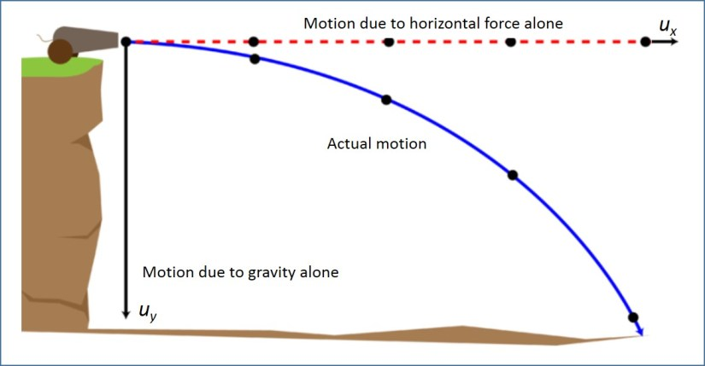

(a) Time to Hit the Ground
Using vertical free-fall equation (vy₀ = 0):
h = ½gt²
45 = ½ × 9.8 × t²
t² = 90 / 9.8 = 9.18
Answer (a) | t = √9.18 ≈ 3.03 s

(b) Horizontal Distance
Using parabolic equation with θ = 0° (or x = vx · t):
x = v_{x} × t
x = 15 × 3.03
Answer (b) | x ≈ 45.46 m

(c) Final Velocity at Impact
Vertical velocity just before impact:
v_{y} = g × t = 9.8 × 3.03 = 29.7 m/s
Resultant (combined) velocity:
v = √(v_{x}² + v_{y}²) = √(15² + 29.7²) = √(225 + 882)
Answer (c) | v = √1107 ≈ 33.3 m/s at angle tan⁻¹(29.7/15) ≈ 63° below horizontal

10. Projectile Motion & Software Engineering
For software engineering students, projectile motion is far more than a physics exercise. It is the mathematical foundation of numerous important computing domains.

10.1 Game Development & Physics Engines
Every major game engine (Unity, Unreal Engine, Godot) implements a physics system rooted in projectile kinematics. When a character throws a grenade, fires an arrow, or a ball bounces, the engine computes:
- Parabolic trajectories using y = x tanθ - gx² / (2v₀²cos²θ)
- Prediction of landing points using the range formula R = v₀² sin(2θ) / g
- Optimal launch angles (45° for maximum range)
Software engineers who build games must implement these equations efficiently in C++, C#, or GDScript, often extending them to 3D.

10.2 Robotics & Drone Programming
Modern robots and drones rely on kinematic models for path planning:
- Robotic arms in warehouses compute throw-and-catch trajectories in real time
- Drone delivery systems calculate minimum-energy flight paths using projectile approximations
- Mars rovers use ballistic equations to model the flight of ejected rocks and safe landing trajectories

10.3 Computer Graphics & Animation
Visual effects and animation in films and games are governed by the same physics:
- Particle systems (explosions, water droplets, sparks) each follow projectile paths
- CSS and JavaScript canvas animations use kinematic equations to simulate realistic object motion
- 3D rendering engines compute light particle trajectories for physically-based rendering (PBR)

10.4 Artificial Intelligence & Machine Learning
AI agents trained to interact with physical environments learn projectile motion implicitly:
- Reinforcement learning (RL) agents for robot throwing tasks internalize launch-angle optimization
- Physics-informed neural networks (PINNs) directly encode projectile equations as constraints
- Computer vision systems use parabolic fitting to detect and track thrown objects in video

10.5 Simulation & Scientific Software
Many critical software systems are built on projectile physics:
- Ballistic simulation software for aerospace and defense systems
- Sports analytics platforms compute optimal throwing angles from sensor data
- Fluid dynamics simulators model particle trajectories in flows (a generalization of projectile motion)

10.6 Augmented Reality (AR) & Mobile Apps
AR applications overlay real-world physics simulations on camera feeds. Apps that:
- Show the predicted path of a basketball shot before release
- Animate the flight path of a golf ball after it is struck
- Simulate projectile trajectories interactively for training or education
... all require efficient, real-time computation of the parabolic equations derived in this document.
Conclusion
Mastering projectile motion gives software engineering students a powerful tool: the ability to model, simulate, and animate the physical world. The equations derived here — the parabolic path, maximum height, time of flight, and range — are building blocks that appear throughout game engines, robotics, AI, and simulation software. Physics and programming are deeply intertwined, and kinematics is the bridge between them.

